Uva Wellassa University of Sri Lanka Faculty of Applied Sciences  Department of Computer Science and Informatics  Undergraduate Research Project (CST/IIT)- 2024/2025 |  |  |  | 
PROGRESS REPORT Report No: |  |  |  | 07
Name of the student/s: | W.K.Gayan
Registration Number/s: | UWU/IIT/21/062
Degree Programme/s: | Industrial Information Technology
Title of the Study: | AI-Based Tomato Ripening Stage Detection and Sorting System with Shelf-Life Estimation for the Commonly Consumed Padma Variety in Sri Lanka Using Computer Vision and Conveyor Automation
Institute/s where studies  are affiliated with: | Uva Wellassa University of Sri Lanka
Name of the Supervisor/s: | Ms. D.P. Jayathunga(Principle supervisor)  Dr. U.G.A.T. Premathilake (Co-Supervisor)  Ms. M.P.A.M. Rathnakumara (Co-Supervisor)
Period of Progress: | From:14/06/2026 |  | To:08/07/2026
Progress (A description by the student).
1) Accomplished Activities

During this reporting period, significant progress was achieved in the hardware development and mechanical integration of the prototype. The primary focus was on completing the conveyor mechanism, integrating the drive system, acquiring the required electronic components, and performing initial hardware testing to validate the operational stability of the conveyor platform.

All major electronic and mechanical components required for the prototype were successfully procured. These include the ESP32 development board, NEMA 23 stepper motor, stepper motor driver (DM543), 24 V 5 A power supply, 12 V 2 A power adapter, MG995 servo motors, timing belt and pulleys, servo mounting brackets, motor mounting bracket, circuit boards, jumper wires, soldering materials, and other essential electronic accessories. The availability of these components enables the completion of the remaining hardware integration activities.

The conveyor assembly was successfully completed by installing the conveyor rollers, bearings, shafts, and supporting frame components. Following assembly, the conveyor rolling mechanism was thoroughly tested to evaluate its performance. Mechanical issues encountered during the initial movement were identified and corrected by adjusting the alignment of the rollers and improving the stability of the rotating components, resulting in smooth and reliable conveyor operation.

The NEMA 23 stepper motor was mounted securely using an L-shaped motor mounting bracket and mechanically coupled to the conveyor drive roller through a pulley and timing belt transmission system. An 8 mm bore 20-tooth pulley was installed on the motor shaft, while a 10 mm bore 60-tooth pulley was attached to the conveyor roller. Both pulleys were connected using a closed-loop timing belt, providing efficient torque transmission and stable conveyor movement.

On the electronics side, the initial control system was developed using the ESP32 development board and the DM543 stepper motor driver. A preliminary control program was implemented to drive the stepper motor using the 24 V 5 A power supply. The conveyor system was successfully operated under programmed control, demonstrating stable and continuous belt movement.

Finally, functional testing of the assembled conveyor was carried out using fresh tomatoes to evaluate its practical operation. The conveyor transported tomatoes smoothly with consistent speed and stability, confirming that the mechanical design and drive system are suitable for subsequent integration with the computer vision-based ripeness detection and sorting modules.

Milestones Achieved
- Successfully procured all major electronic and mechanical components required for prototype development.
- Completed the assembly of the conveyor mechanism, including rollers, bearings, shafts, and supporting frame.
- Tested and optimized the conveyor rolling mechanism by resolving alignment and movement issues.
- Installed the NEMA 23 stepper motor using a dedicated motor mounting bracket.
- Integrated the pulley and timing belt transmission system between the motor and conveyor roller.
- Developed the initial ESP32-based motor control program using the DM543 stepper motor driver.
- Successfully operated the conveyor using the 24 V 5 A power supply and validated stable conveyor movement.
- Conducted preliminary conveyor testing using fresh tomatoes and verified smooth, steady transportation.
- Established a functional hardware platform for the integration of the vision-based tomato detection and automated sorting system.

Figure 1: Motor assembly showing the NEMA 23 stepper motor, pulley system, timing belt, and motor mounting bracket.

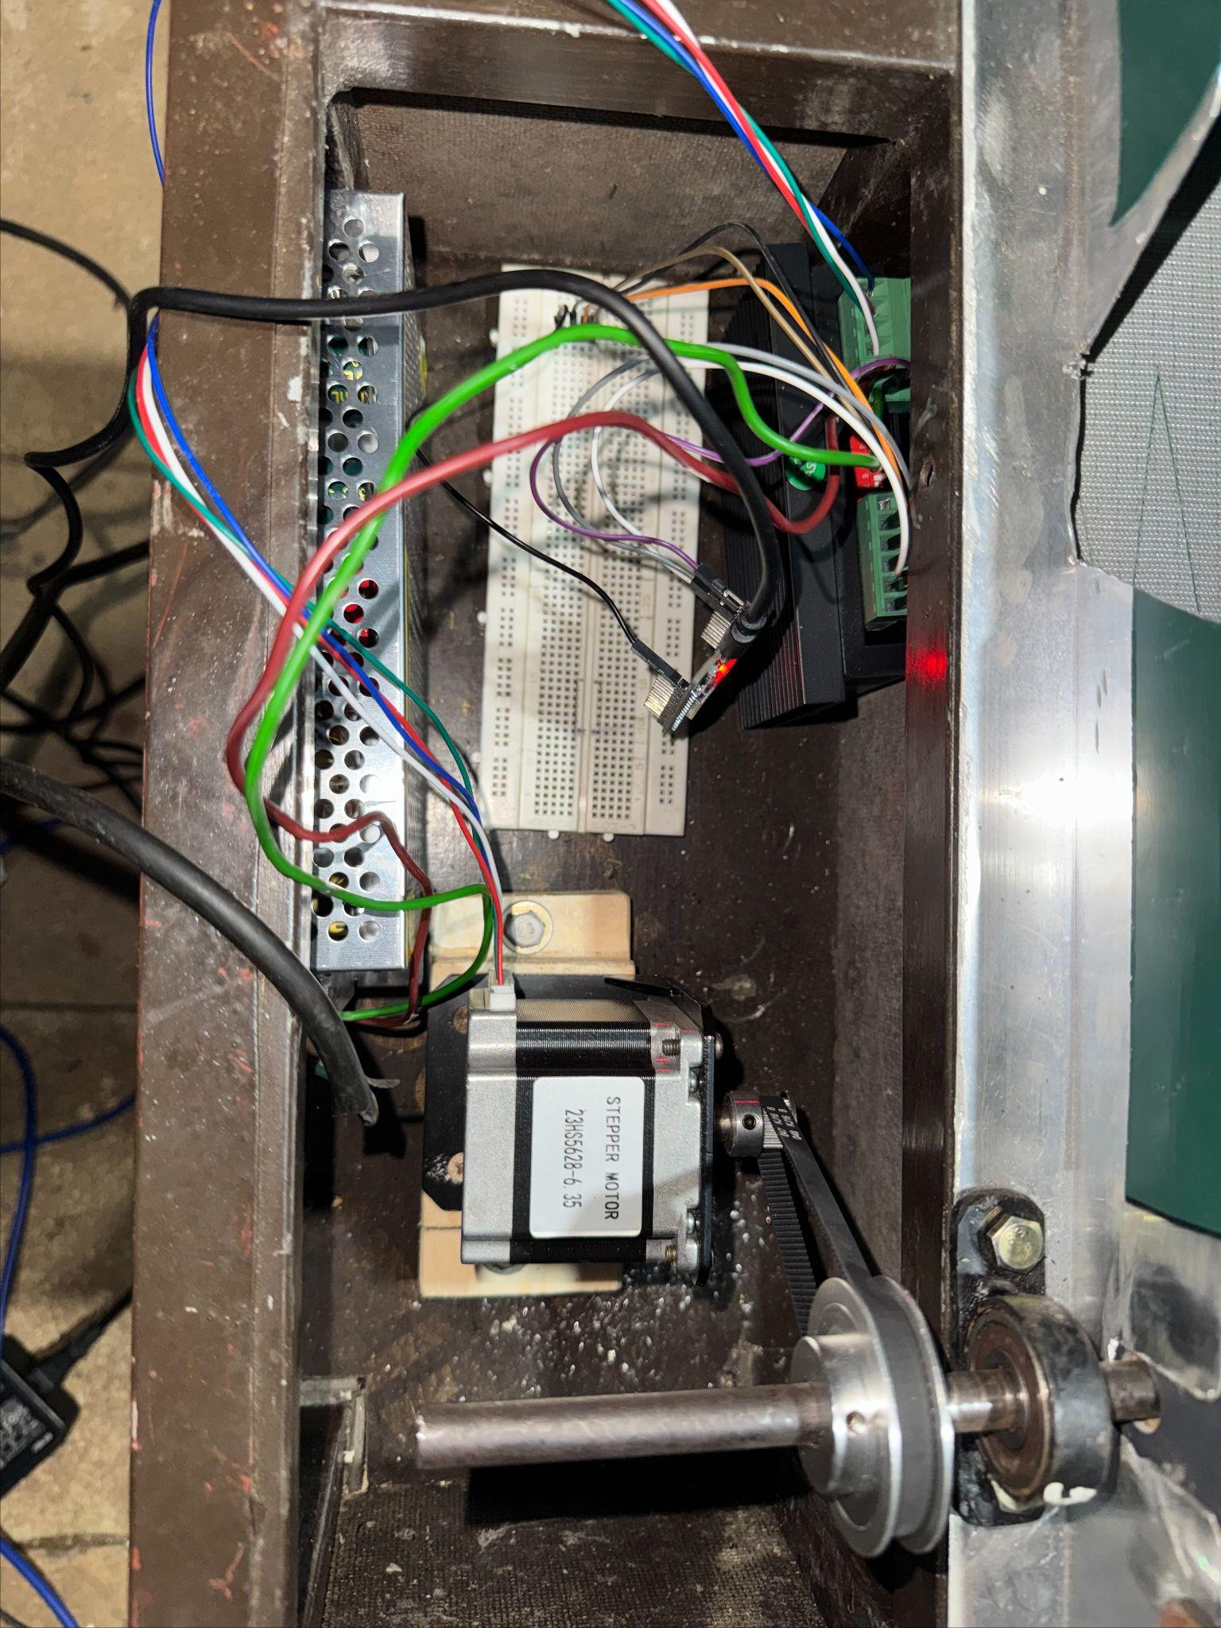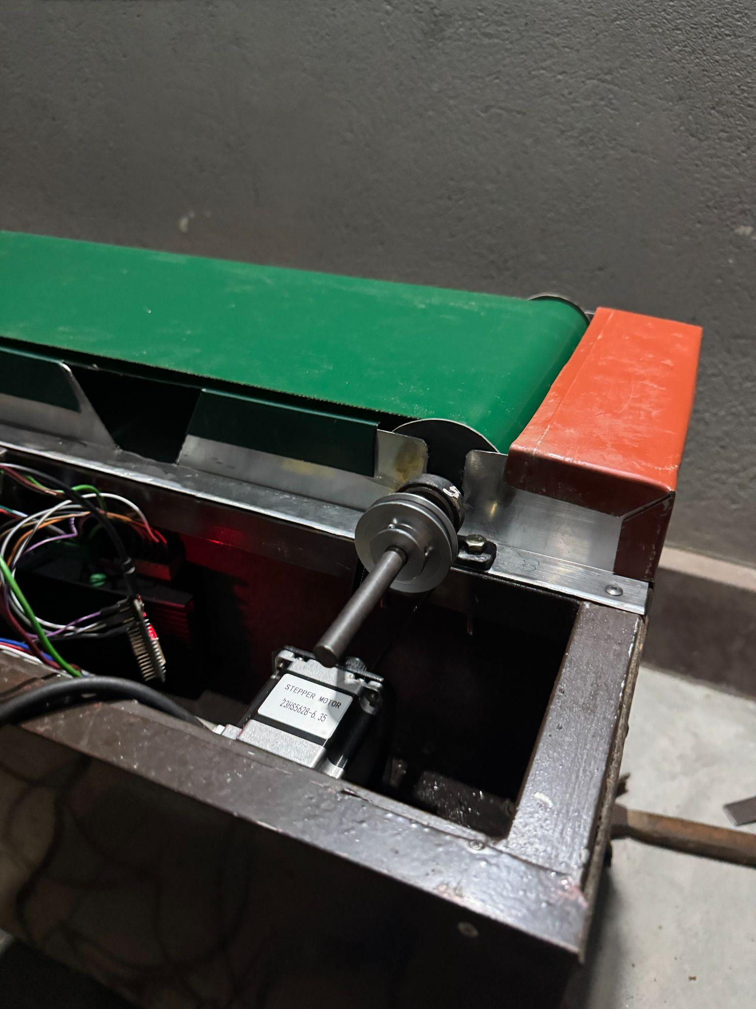

Figure 2: Overall prototype structure with the completed conveyor assembly and integrated mechanical components.

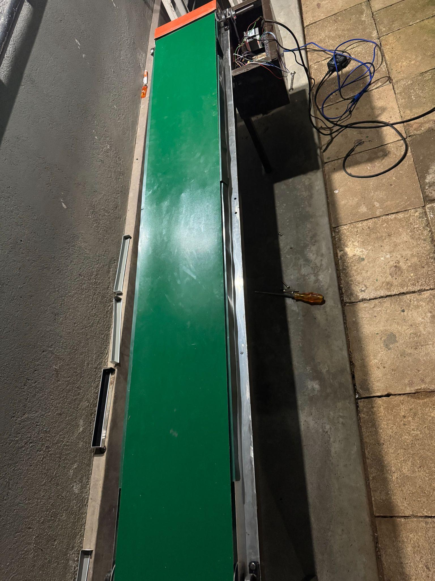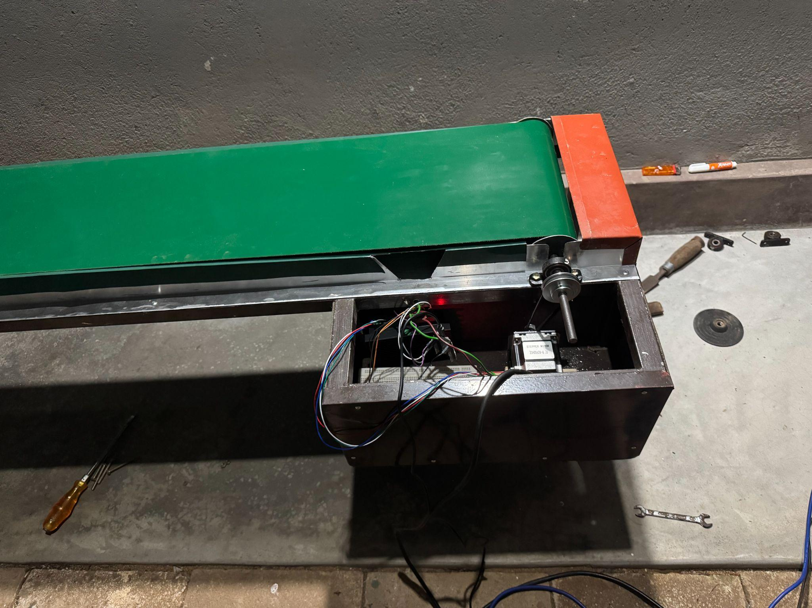

2) Activities Planned for the Next Period

The next phase of the project will focus on completing the automation and intelligent sorting components of the prototype by integrating the remaining hardware with the computer vision system.

Planned Activities
- Install and configure the MG995 servo motors with the sorting mechanism.
- Complete the fabrication and installation of the automated sorting section.
- Integrate the ESP32 controller with the servo motors and conveyor control system.
- Mount and calibrate the camera for image acquisition.
- Integrate the trained tomato ripeness detection model with the hardware prototype.
- Establish communication between the computer vision system and the ESP32 controller for automated sorting.
- Perform integrated hardware and software testing using real tomato samples.
- Optimize the overall performance of the complete prototype prior to final evaluation.
Signature of the Student: |  | 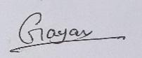
Approval Signature of Supervisor:
Approval Signature of Co-Supervisor (If any):
Date: |  | 08/07/2026

